

Insulated Metal Panels (IMP) – Quick Reference Guide

**Wall Panel Attachment**

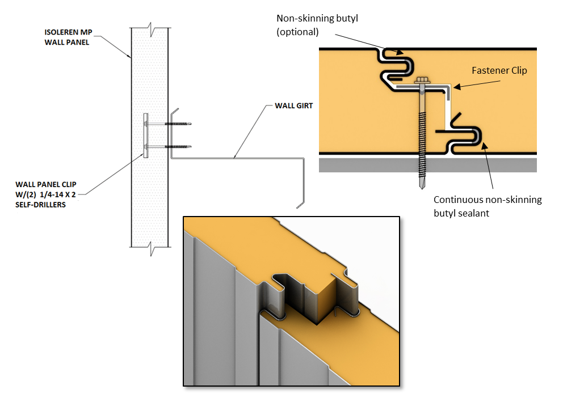

**Insulated Metal Panel Profiles**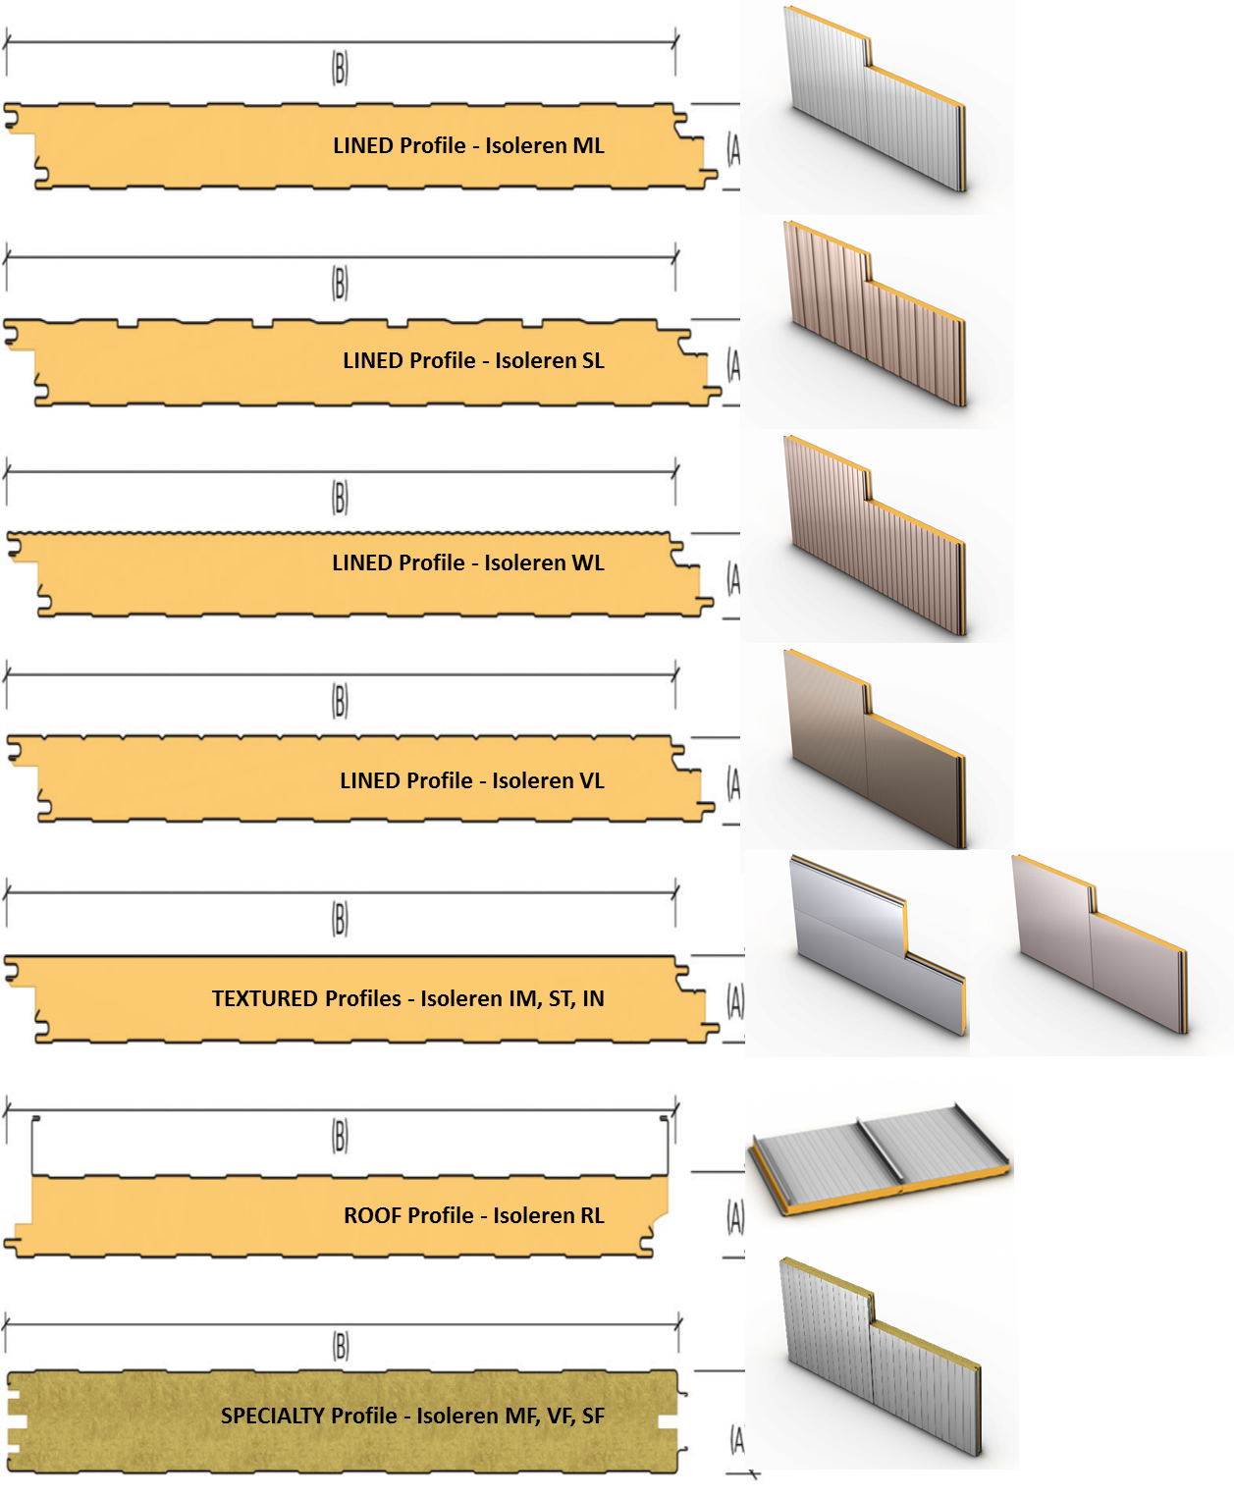

**Colors**

