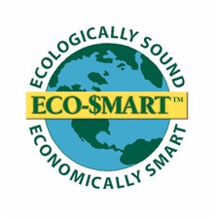
ECO-$MART, Inc.

Please Contact Me After this Event

Name: ____________________________________________
Phone #’s (Cell, Work): _______________________________
Email: _____________________________________________
Business name: _____________________________________
Address: ___________________________________________
City: ____________________ State: _________ Zip: _______

Products I’m Interested in:
□ Energy Efficient Mortgage | □ Low-E / Impact windows & doors
□ Available Tax Credits | □ Brac grey water recycling
□ Concrete & SIP walls or roofs | □ Hurricane Safe Rooms
□ Passive Solar water heating | □ Bio-based Spray Foam Insulation
□ High Efficiency(water-cooled) Air Conditioning | □ Eco-Flector radiant barrier
□ Membrane Energy Recovery Ventilator - ERV | □ Atmospheric Water Generator
□ Zero VOC paints | □ Radiant under-floor heating
□ Solar – Photovoltaics (specify below) | □ Metal roofing options
□ Eco-shake roofing | □ Storm panels - hurricane
□ Lighting- CFL or Electronic Ballast fixtures | □ Lighting- L.E.D. / fiber-optic
□ Recycled Composite decking material | □ Permeable paving options
□ Water purification | □ Chlorine free pool sanitation
□ Flapper-less or dual flush toilets | □ Countertops- Torzo, Conch
□ Flooring- Bamboo, Cork, Palm, Teak, Pine, | □ Marmoleum “Click”
□ Rubber flooring | □ Wool, Sisal, Seagrass, carpeting
□ Cabinetry wood- bamboo, Kirei | □ Florida Landscaping
Other Questions: ______________________________________
________________________________________________________________________________________________________________________________________________________________________________________________________

